**Finding & Analysis**

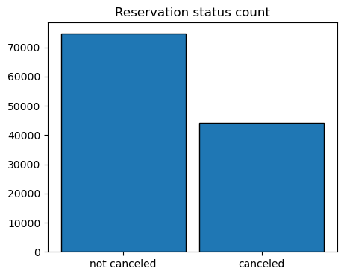

The accompanying bar graph shows the percentage of reservations that are cancelled are those that are not. It is obvious that there are still a significant number of reservations that have not canceled. There are still 37% of clients who canceled their reservation, which has a significant impact on the hotel’s earnings.

In comparison to resort hotels, city hotels have more bookings. It’s possible that resort hotels are more expensive that those in cities

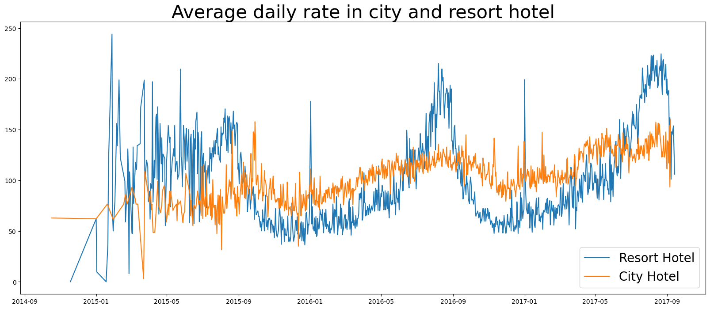

The line graph above shows that, on certain days, the average daily rate for a city hotel is less than that of resort hotel, and on the other days it is even less. It goes without saying that weekends and holidays may see a rise in resort hotel rates

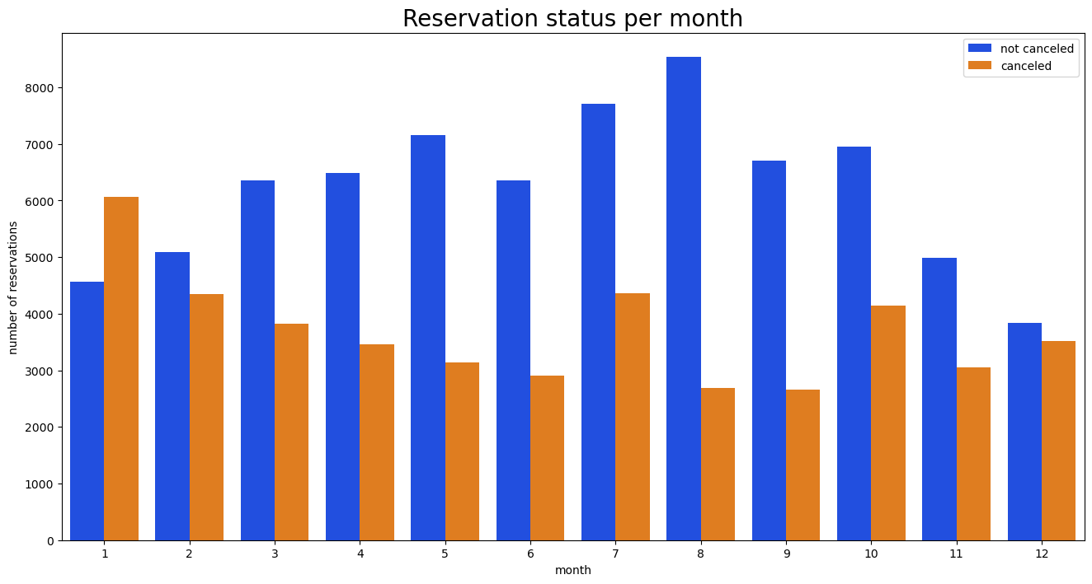

We have developed the group bar graph to analyze the months with the highest and lowest reservation levels according to reservation status. As can be seen, both the number of confirmed reservations and the number of canceled reservations is largest in the month of August, whereas January is the month with the most canceled reservations

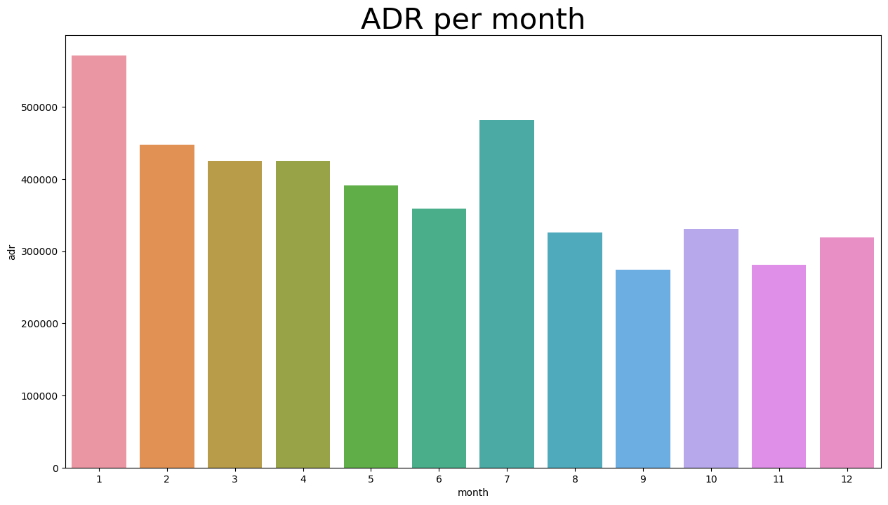

The bar graph demonstrates that cancellations are most common when prices are greatest and are least common when they are lowest. Therefore, the cost of the accommodation is solely responsible for the cancellation.

Now let’s see which country has the highest reservation canceled. The top country is Portugal with the highest number of cancelletions.

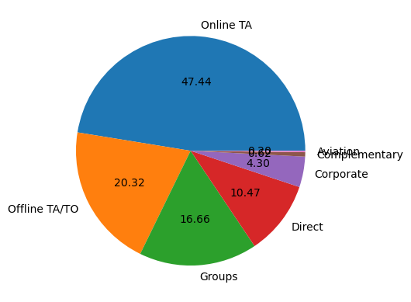

Let’s check the area from where guests are visiting the hotels and making reservations. It is coming from Direct or groups, online or offline Travel agents?

Around 46% of the clients come from online travel agencies, whereas 27% come from groups. Only 4% of the client’s book hotels directly by visiting them and making reservations.

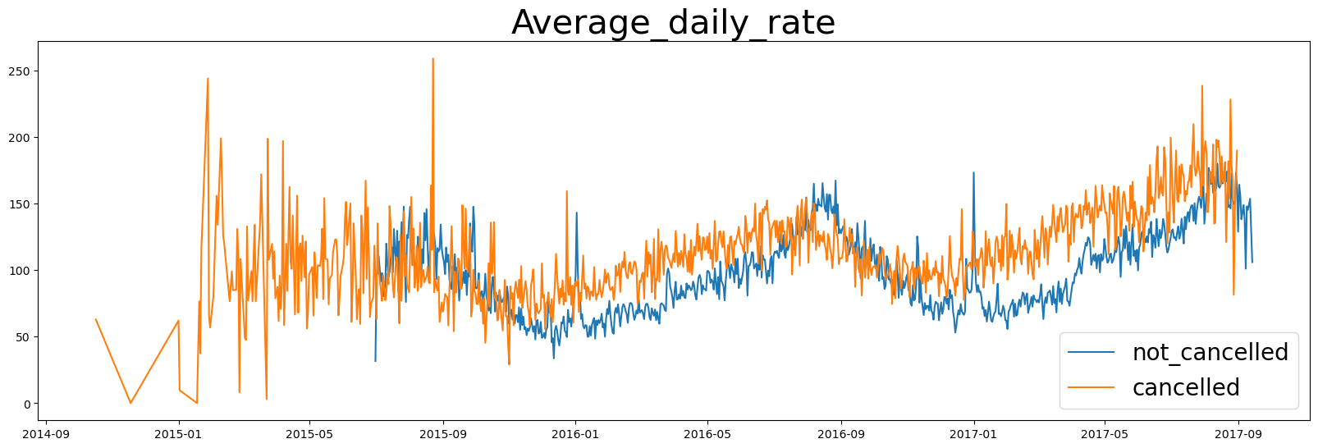

As seen in the graph, reservations are canceled when the average daily rate is higher than when it is not canceled. It clearly proves all the above analysis, that the higher price leads to higher cancellation.